Imaging metal corrosion – pre-plated agar

AIM
To observe the corrosion of different metals, and understand the electrochemical processes at play

YOU WILL NEED

- Pre-plated agar in plastic petri dish
- raw steel (steel nail)
- copper (sheet or wire)
- zinc foil
- fine sand paper

PROCEDURE
Sand down any metal samples with fine sandpaper, and wash and dry before using. Decide on which metal samples you wish to look at in each petri dish. It is a good idea to compare 1) copper, 2) steel, 3) steel wrapped in copper, and 4) steel wrapped in zinc. Prepare these samples ready for your agar dishes.
Take a pre-plated agar dish, and remove the plastic lid. Carefully push your metal sample into the agar – try not to touch the agar too much as it is delicate. Replace the lid on the plate, and wash your hands.
Leave the samples for 1-2 days, and then observed what has happened.
QUESTIONS
- Draw what has happened to each of your samples, marking areas of blue/purple agar associated with reduction sites (cathode). Compare the steel sample to the copper sample – which reduces oxygen more easily?
- At the anode sites of the steel nail, oxidation of iron is occurring, initially to form Fe(II) ions. What happens to the agar at these sites? If you leave the dishes for several days you can see an orange/brown solid forming, what is this product?
- Compare the effect that copper and zinc have on the corrosion of the steel nail. Does the section of steel nail wrapped in copper/zinc corrode more or less in each case? How is this method used to protect metals from rusting?
- Why do you think we add salt to the agar to speed up the corrosion? (hint – what needs to move from the anode to the cathode?)

The electrochemistry at play:
The corrosion process occurs due to the metal oxidising, and forming ions in solution, but what is accepting the electrons and reducing?
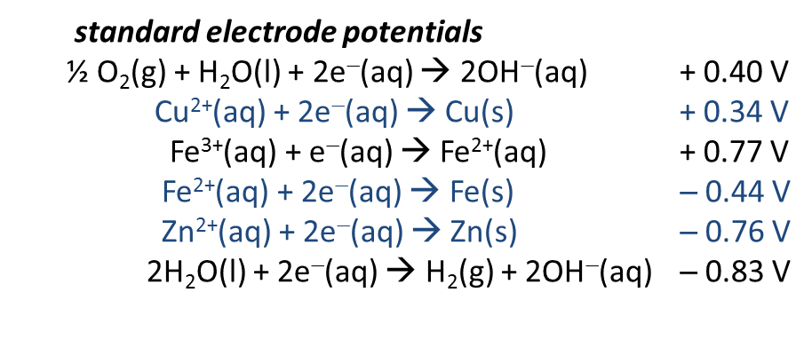
Water cannot reduce to form hydrogen gas, unless the metal which is oxidising has a standard electrode potential (for the reduction of its ion to give the metal) that is more negative than -0.83 V.
The species which is reducing in all of these systems is oxygen, which is dissolved in the water/agar gel. The oxygen reduces to form hydroxide ions, in the presence of copper, iron and zinc. Zinc is more reactive than iron, which is more reactive than copper, because zinc gives up its electrons to form Zn²⁺ more readily, and hence the standard reduction potential for Zn²⁺/Zn is more negative.
For the single steel nail embedded in agar, the agar starts to go blue/purple where the reduction is occurring, due to the formation of OH–, and this is the cathode (positive charge). At different sites on the nail, iron is oxidising to form Fe²⁺ and Fe³⁺, which form acidic complexes in water, and the agar will start to go orange/red. This indicates the anode sites.
Zinc gives up its electrons more easily than iron, so it preferentially gives electrons to the oxygen, and also pushes electrons towards the iron, making the iron less likely to corrode. Copper, however, gives up its electrons less readily than iron, so it pulls electrons away from the iron, making it more likely to oxidise (corrode

