Fuel Cells for Future Energy

AIM
To make a working fuel cell

YOU WILL NEED

- 2 insulated wires with crocodile clips
- a voltmeter
- an LED
- 2 pencils (sharpened at both ends)
- tape
- blu tack
- beaker
- 0.4 M KOH (aq)
- 1 x 9 V battery

PROCEDURE
Step 1 – Make your fuel
First you need to make your fuel; your hydrogen and oxygen gas. We will do this by splitting water, using electricity:
We USE electrical energy to force a chemical reaction – this is called ELECTROLYSIS:
- 2H₂O _H₂(g) + _O₂ (g) balance the equation

- In the process of electrolysis, what type of energy is being converted into chemical energy?
_________ Energy Chemical energy
Take the two pencil electrodes, and tape them together, using a piece of blutac in between the pencils, to space them, about a pencil width apart.
We will come round and fill your beaker with potassium hydroxide solution for you. WARNING – this solution causes skin irritation and eye irritation. WEAR GOGGLES. If spilt wash hands immediately.
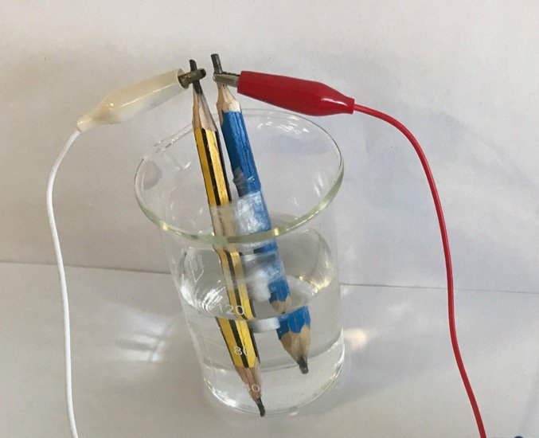

Take your 9 V battery and connect one end of a wire to the +ve terminal of the battery (circular), and the other end to one of the pencils. Mark the pencil with a ‘+’. Use the other wire to connect the –ve terminal (hexagonal) to the other pencil. Mark it with a ‘-‘.

As soon as you connect the battery, the electrolysis should start to happen. Leave it to make your fuel for 2-3 min.
- What can you see happening at the pencil tips in the solution?

- Which electrode (+ve or –ve) produces bubbles faster?
- Which gas (oxygen or hydrogen) do you think you produce more quickly, using your answer to question 1?

- Sketch a diagram of your electrolysis setup below:

The electrolysis process occurring:
(+ve electrode) = Anode 4 OH–(aq) → O₂(g) + 2 H₂O(l) + 4 e–
(-ve electrode) = Cathode 4 H₂O + 4 e– → 2 H₂(g) + 4 OH–(aq)
Step 2 – Make your fuel cell
After 2-3 min of making your oxygen and hydrogen fuel, carefully disconnect the battery. TRY NOT to disturb the bubbles as this is your FUEL!
Connect the electrodes up to the voltmeter, and observe the voltage over 5-10 min. Do this carefully.

- Can you measure a voltage? What happens to the voltage over a few minutes? Why do you think this is?

- Sketch the apparatus for the fuel cell that you have made below:

- In this process occurring in the fuel cell, what type of energy is being converted into electrical energy?
________ Energy Electrical Energy

- What is the overall product when hydrogen reacts with oxygen? Why is this a ‘greener’ process than combustion?

The alkaline fuel cell:
(-ve electrode): 2 H₂ + 4 OH– → 4 H₂O + 4 e–
(+ve electrode) : O₂ + 2 H₂O + 4e– → 4 OH–
Step 3 – Can you light an LED?
Remake your fuel (repeat step one), and then check that you have a measurable voltage. Connect your pencils to an LED and see if it lights? How many fuel cells are needed? You will probably have to connect up with other students fuel cells to get enough power!

