Biopolymers to prevent cancer

Sometimes, the cells in our bodies can start to grow too quickly. When this happens the cells can form tumours.

Some tumours stay in one place and don’t spread to other parts of the body. These are called benign tumours.

Some tumours release cells that invade other parts of the body. This can cause secondary tumours. These tumours are malignant.

Cancers can occur in any place in the body. One type of cancer that we are going to learn about today is bowel cancer. This occurs in the large intestine.
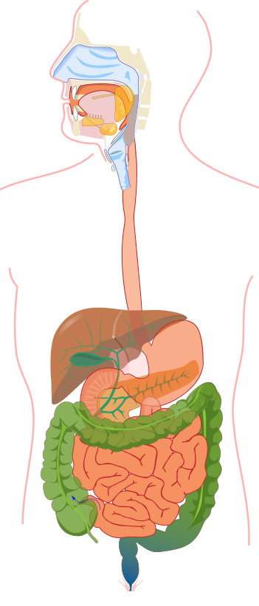

Mouth

Stomach

Small intestine

Large intestine

Scientific research shows that a diet with lots of red meat might put people at higher risk of getting bowel cancer. This is because red meat contains lots of iron and this can irritate the bowel. Bowel cancer is more common in developed countries.

Cancer treatments are always improving. But people still die from bowel cancer so it’s important to come up with new treatments. It’s also important to prevent the disease.

Scientists in Birmingham are using a molecule from seaweed to ‘mop up’ iron in the intestine. This method works because the seaweed molecule is a polymer. It can form something called a gel when it’s mixed with iron.
Polymers
Sometimes small molecules can join together to make long molecules. These are called polymers. A lot of man-made polymers exist. They are often called plastics.

ethylene polyethylene

Lots of living creatures also make polymers.
Crabs make a shell out of polymers for protection against predators.
We have polymers in our bones to make them strong and flexible.

Lots of polymers can be extracted from living creatures. We use these polymers in our everyday lives. You can find them in many foods. This is because they form gels.

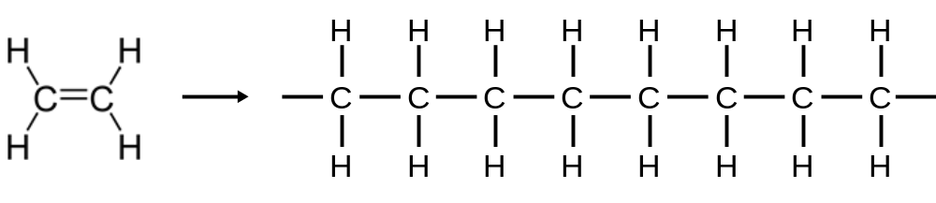

The polymer we get from seaweed is called alginate. It could be really useful for preventing bowel cancer as it forms a gel with iron.

The trouble with alginate is that it also forms gels with other metals. We have lots of calcium inside our bodies. The alginate might just react with the calcium and ignore the iron.

One thing we can try is different types of alginate. The alginate molecule is different depending what type of seaweed you get it from. Squeeze some kelp and sea lettuce between your fingers. They feel different because they have different types of alginate in them.

Aim
Different seaweeds contain different alginates. We’re going to compare two and see whether they form gels with iron or calcium.

Method
Start with the high-G alginate (green). Use a pipette to drop some of the alginate into a solution of iron chloride. Then try calcium chloride. What happens to the drops? What do they feel like? Now try the same experiment with high-M alginate (red).
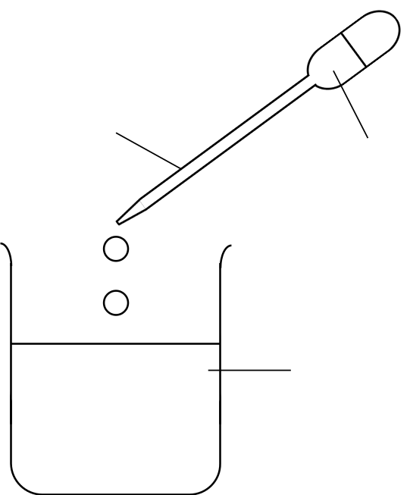

Pipette
Alginate solution

Metal chloride solution

Results
 | High-G alginate | High-M alginate
Iron chloride solution
Calcium chloride solution

Conclusions

Did you notice any difference between the alginates with iron? How about with calcium? Was one alginate better at forming gels with calcium?

If you wanted to use an alginate to ‘soak up’ iron in the bowel but leave calcium alone, which one would you choose? Why?

How does alginate work?

Polymers make gels in different ways. Gels work by trapping water molecules. Use pieces of string to make a ‘gel’ structure. Tie the strings together where they cross using cable ties. Sketch your gel:

In alginate, the metals are like the cable ties. They make the alginate molecules stick to each other. The water molecules get trapped in between.

