PROTEIN BUILDING BLOCKS
Exercise 1:
Have a go at building some (very small) proteins! Try and work out which amino acids form from each of these amines and acids. If you can, think about why the bonds are forming at the specific atoms you have chosen
1
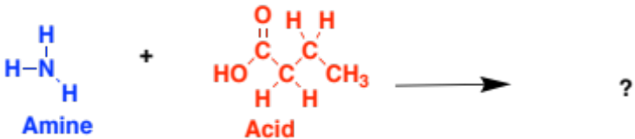

2
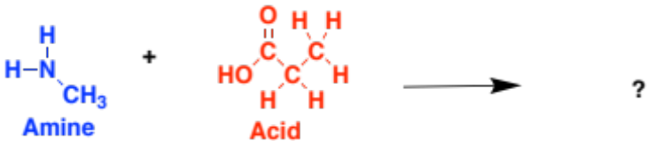

3
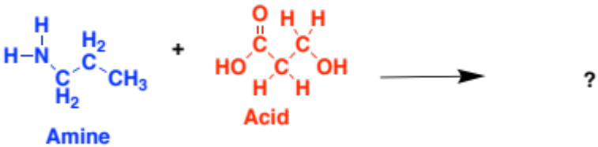

Now see if you can combine these three amino acids to form a peptide!

Extension:
Remember the order of amino acids in the chain is very important for the properties of the protein. Try and rearrange the order of amino acids to form a different peptide chain.

