PROTEIN BUILDING BLOCKS
Exercise 2:
Take a piece of string. This represents the primary structure of a protein. Wrap it around your hand in a helix (corkscrew) shape. When you remove it from your hand you will lose the shape of the protein.
However, if you add bag clips to the string, you can keep the alpha helix shape. These clips represent hydrogen bonds.
Now, with a partner, use more clips to join your polymer chains together forming the beta sheet structure.
Finally, with different coloured clips showing the different potential intermolecular bonds from the amino acid side chains, attach many different parts of the proteins together to form the 3D shape- the tertiary structure.
Now, with your complete structure, it is time to denature the protein. Undo all of the clips.
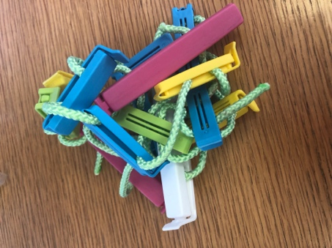
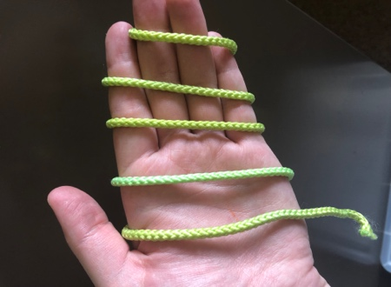
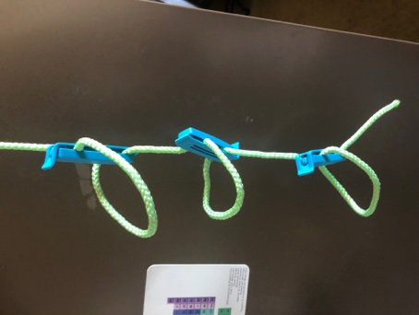
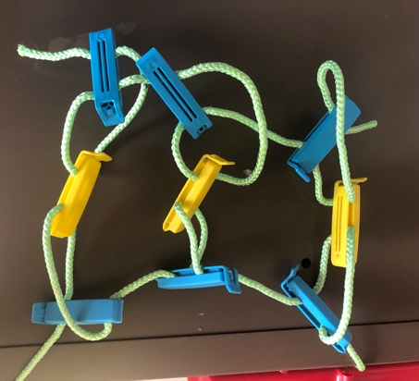
What happens to the primary, secondary and tertiary structure of a protein when it is denatured? What will we observe happening to the protein?

