PROTEIN BUILDING BLOCKS
The Experiment
AIM
To separate out the protein from a spirulina tablet and test the effect of different additives on the protein structure.
YOU WILL NEED
- 1 spirulina tablet
- 5 test tubes
- 150 mL of deionised water
- funnel
- filter paper
- torch (a phone torch is fine)
- Bunsen burner
- tripod
- 10 drops 0.5 M hydrochloric acid
- washing up liquid
- thermometer
- One egg
- Glass beaker
PROCEDURE
Part 1 - Spirulina
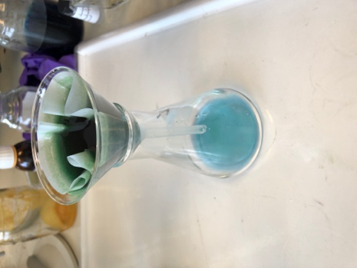
Crush a spirulina tablet into a fine powder and dissolve it in 150 mL of deionised water, stirring to help dissolution. This will take roughly 15 minutes
Filter to remove the undissolved chlorophyll until you get roughly 20 mL of the protein solution. Record any observations, e.g. changes in colour.
Add approximately 2 cm of the protein solution into each of 5 test tubes.
Using a torch, shine a light on the protein, recording the colour that you observe.
Leave one test tube as a control.
In test tube 2, add 2 drops of washing up liquid and shake. Note any colour changes. Shine the light on this solution, compare to test tube 1 and note any changes in fluorescence.
In test tube 3, add 5 drops of 0.1 M hydrochloric acid and shake. Note any colour changes. Shine the light on this solution, compare to test tube 1 and note any changes in fluorescence.
Now add another 5 drops of 0.1 M hydrochloric acid and shake. Note any colour changes. Shine the light on this solution, compare to test tube 1 and note any changes in fluorescence.
Finally, place test tube 4 in a water bath placed on a tripod. Start heating the water bath, keeping an eye on the temperature and the solution. For every 10 ºC, note your observations of the protein solution, and any changes in fluorescence.
Once you notice a significant change in colour/fluorescence, take this test tube out of the water and leave to cool back to room temperature. Note any colour changes. Shine the light on this solution and note any changes in fluorescence. How does this compare to the heated sample?
At (or above) the same temperature that you removed test tube 4 from the water, heat test tube 5 for approximately 10 minutes. Note any colour changes. Shine the light on this solution and note any changes in fluorescence. Leave this to cool to room temperature and compare to test tube 4.
Part 2 – Egg white
Note: this part of the experiment doesn’t necessitate practical work and can just be discussed theoretically.
Crack open an egg and separate out the egg white from the yolk.
Put the egg white into a glass beaker above a Bunsen burner and heat it.
Note any changes that occur and think about what is happening to the protein structure.
Once you see a permanent change, remove the egg white from the heat and leave to cool to room temperature, or on ice. Note any changes in the protein structure of the egg white.

QUESTIONS
- As well as the protein, the spirulina tablets also contain chlorophyll. Why doesn’t this dissolve? What would happen if we tried to dissolve it in methanol?
- When you shine a torch on the protein what colour is it? What colour must the protein be absorbing? For more information on fluorescence take a look at the sensing with fluorescence experiment https://chembam.com/experiments/sensing-with-fluorescence/
- What happens to the fluorescence of the protein after heat/acid/soap?
- What do the observations in question 3 suggest has happened to the protein? Think about your answer in terms of molecular interactions.
- What happens to the heated protein in test tubes 4 and 5 when they return to room temperature? What conclusions can you draw from this?
- What happens to the protein structure of the egg white when you heat it? Does anything change when it is cooled? What can you determine from this?

