FRACTIONAL DISTILLATION
AIM
To separate a fizzy drink into its ingredients by fractional distillation.
YOU WILL NEED
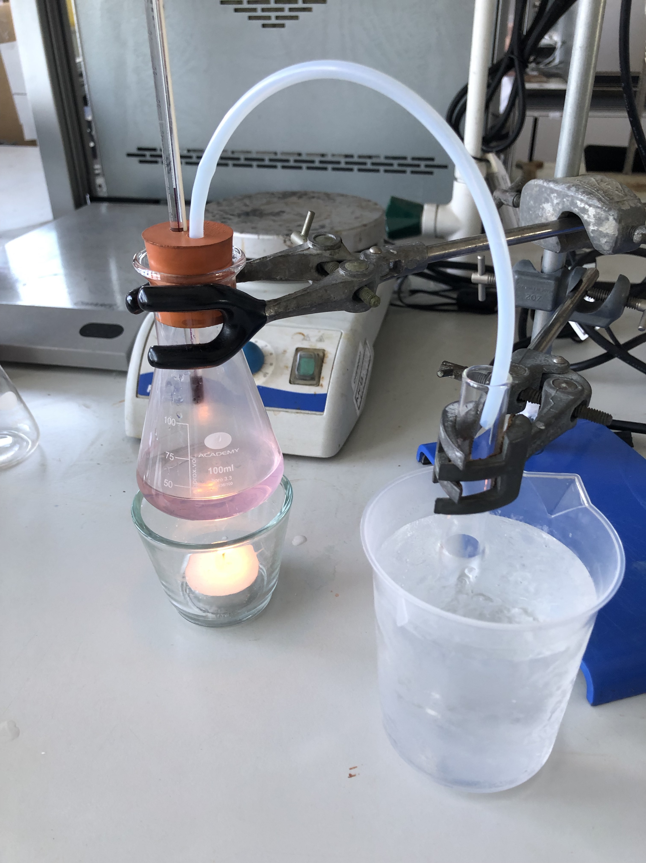
- 100 ml conical flask
- Tripod/stand and clamp
- 5 Test tubes/vials per group
- Test tube holder
- Heat source - hot plate or tealight (not bunsen burner)
- Fizzy drinks
- Universal indicator
- Ice
- Large beaker/container to hold ice
- Rubber bung with two holes
- Plastic/ Teflon tubing
- Thermometers
- Aluminium foil
PROCEDURE
NOTE: do not use a bunsen burner for this experiment as it is too difficult to control heating.
Part 1: release of CO₂
Measure out 25 mL of the soft drink into a conical flask and weigh. Fill a test tube/vial ¾ of the way full with tap water. Add 1 mL of universal indicator and note the colour and pH of the tap water. Place the conical flask on top of the tripod or clamp it securely. Push the thermometer through one of the holes in the bung and the tubing through the other. If there is an issue with getting the thermometer or tubing through the bung add a bit of washing up liquid to the the end that you want through the bung. The thermometer should rest above the liquid and measure the temperature of the vapour. Carefully fit the bung on top of the conical flask making sure that there is a tight seal, and put the other end of the tube in the universal indicator solution. Place the heat source under the conical flask. Gently heat until the thermometer reads around thirty degrees, or there is a consistent release of gas. As the gas passes through the universal indicator solution in the test tube/vial note the colour change and the pH.

Part 2: distillation of odorous compounds
Fill a beaker or container with ice, and place a second test tube/vial in the ice. Swap the tube that is running into the first test tube and place it in the second test tube. Gently increase the heat of the soft drink until it begins to boil and produce a distillate. Collect the distillate up to about 5 mL then remove the test tube/vial from the beaker/container. If you want to increase the rate of distillation, you can wrap the flask and tubing with aluminium foil cladding.
Part 3: distillation of the water
Place a third test tube/vial in the beaker/container of ice, and swap the tubing from the second test tube to the third test tube/vial. Maintain the heat on the soft drink and collect the remaining distillate. Observe what remains in the conical flask. Compare the smell of test tube 2 and test tube 3. Keep collecting fractions until all the liquid has boil
This reaction can take a very long time to run until completion. If you do not have time to allow all of the liquid to boil off and leave a solid, collect whatever liquid you may have and weigh it.

QUESTIONS
- What happened to the pH of the water after the CO₂ from part 1 of the distillation was ran through it and why?
- Which fractions had the highest and lowest boiling points? Write a list of the different fractions that came off the mixture in order of their boiling point from lowest to highest.
- What remains in the conical flask after the distillation was over? What difference would you expect to see in a “diet” version of this drink?
- What was the initial density of the fizzy drink? What is the final density of the fizzy drink? Can you give an explanation for any changes? Think about what you have collected in your fractions and what is left in the conical flask.
- What did fractions 2 and 3 smell like? Why is it important that these molecules have relatively low boiling points?
- Below is a diagram of a distillation column. Fill in the boxes for where you think that your fractions from your fizzy drinks would be removed.
