Adsorption vs Absorption
Adsorption and absorption mean quite different things.

Absorption
Absorption is where a liquid is soaked up into something like a sponge, cloth or filter paper. The liquid is completely absorbed into the absorbent material.
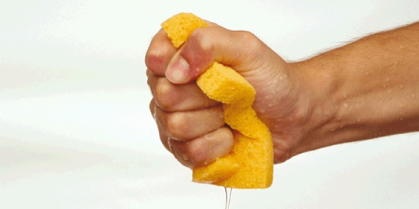
Image of sponge absorbing water.

Adsorption
Adsorption refers to individual molecules, atoms or ions gathering on surfaces. The surface of a material is made up of atoms and bonds that are exposed to the air. For example, the surface of a piece of glass will be covered in silicon and oxygen atoms. Molecules or ions can interact with this surface via intermolecular interactions. This allows them to 'stick', or adsorb, to the surface. If a material has a very high surface area, then lots of molecules can stick to the surface.
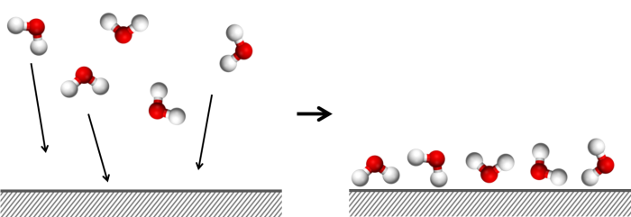

Image of molecules adsorbing onto a surface.

