AFM (Atomic Force Microscopy) vs STM (Scanning Tunnelling Microscopy)
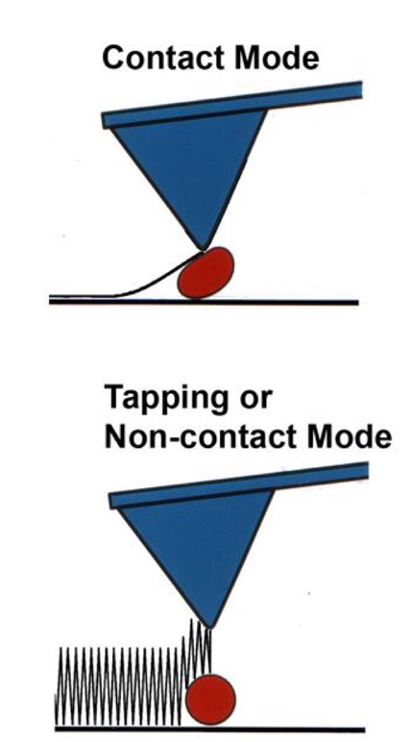

Atomic force microscopy (AFM)
Atomic force microscopy (AFM) sometimes referred to as scanning force microscopy (SFM) is a microscopy technique used to give a topographical image of a surface i.e. allows the analysis of the shape and features of the surface. It has relatively good resolution, though not as good as scanning tunnelling microscopy (STM).

There a two different types of imaging modes for AFM, contact mode and tapping/non-contact mode. In contact mode, the probe is brought into contact with the sample and scanned with the force kept constant (or height). This is a more destructive technique and only relevant for a relatively even surface. Alternatively, in tapping/non-contact mode the probe oscillates on/off the surface making it a less destructive technique.

Scanning tunnelling microscopy (STM)
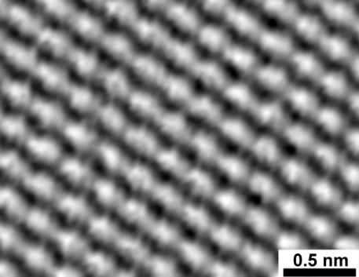
Scanning tunnelling microscopy (STM) is a similar technique, however it involves applying a voltage across the tip/sample to measure the tunnelling current, giving an electrons density of the surface. (read more about the science behind STM here; https://www.nanoscience.com/techniques/scanning-tunneling-microscopy/). STM can offer very high resolution, down to resolving individual atoms, however only surfaces that conduct electricity can be analysed using STM.

Image of a graphite surface at an atomic level obtained by an STM.

