DNA
DNA (deoxyribonucleic acid) is an organic polymer made by the condensation polymerisation of repeating units (monomers) called nucleotides. Each nucleotide consists of a sugar and a phosphate unit (together forming the backbone of the DNA), with the sugar attached to one of the four coding nucleobases; adenine (A), guanine (G), cytosine (C) and thymine (T). These nucleotide monomers are strung together in a line, like the carriages of a train, and DNA is made up of two of these polymers, held together by hydrogen bonding (or H-bonding).
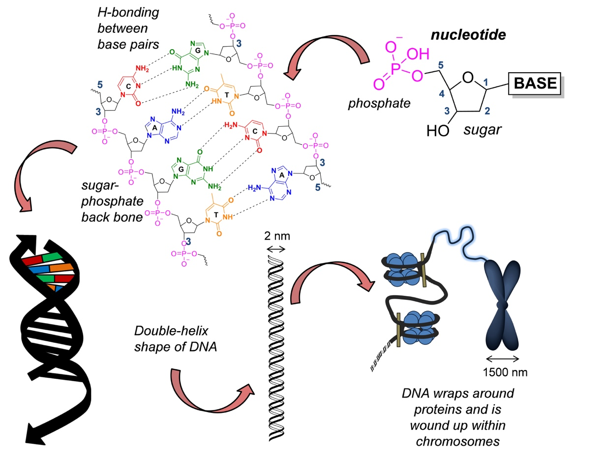

Schematic of DNA; chemistry, structure, size and shape.
The DNA polymer is made by linking the nucleotides via the phosphate at the 5-position and the hydroxyl group at the 3-position, in a condensation reaction. The double-helix shape of DNA was first postulated chemists James Watson and Francis Crick in 1953, and forms due to the H-bonding between bases in one polynucleotide strand and the bases in another strand. The H-bonding is very specific; adenine will only H-bond with thymine, and guanine with cytosine, as the base pairs fit together precisely in terms of size and shape, forming strong H-bond interactions.
DNA records genetic information, within the nucleus of the cell. When a cell divides, a copy of its DNA is made by first unwiding the double helix, and subsequently allowing complementary nucleotides to bind two the two unwound chains, giving two copies of the original DNA molecule.

