Nanotechnology
'Nano-' is a prefix like 'milli-' or 'mega-', meaning 'one thousand-millionth', i.e. 10⁻⁹ therefore 1 nm = 10⁻⁹ m. There are a million nanometres (nm) in 1 mm, and a human hair is approximately 100, 000 nm across.
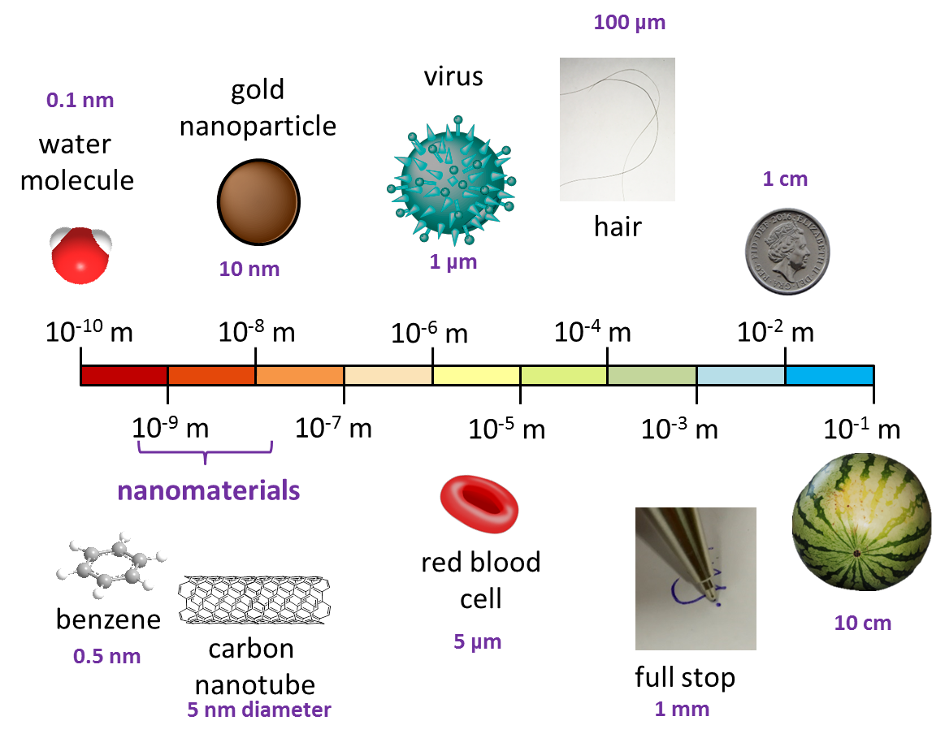
Nanotechnology and nanoscience are associated with structures and materials that are on the nanoscale (between 1-100 nm), and only a tens or hundreds atoms in size.

Nanomaterials, such as gold nanoparticles, can behave quite differently to their bulk material equivalents, because they have huge surface areas for a small volume of material. A high surface-area : volume ratio often makes nanomaterials much more reactive than bulk material composed of the same chemistry.

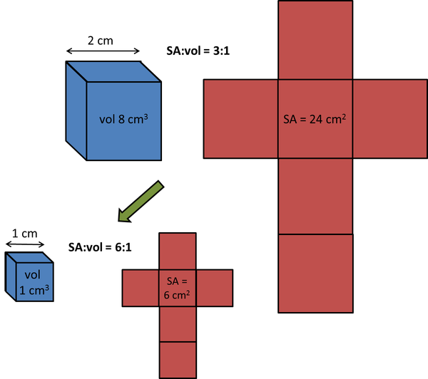
As materials get smaller, the surface-area:volume ratio increases.
Nanomaterials are very useful for developing new catalysts, due to their large surface areas, and are also widely used by the cosmetics industry; nanoparticles are found in face creams, sun-screens and deodorants.
Carbon nanotubes are an example of a 1-dimensional nanomaterial; they are only a few nanometers in diameter, but the wires can stretch much longer distances, a lot like DNA. Carbon nanotubes are being developed as nanowires that conduct electricity for miniaturising electronic devices further and further.
Since the early 21st century, research involving the development of new nanomaterials with biological and medical applications has snowballed into one of the biggest areas of medical technology, because nanomaterials have similar dimensions to most functional biomolecules, such as proteins, DNA, sub-cellular structures. There is great potential to use gold nanocages to deliver drugs into the body, for example.
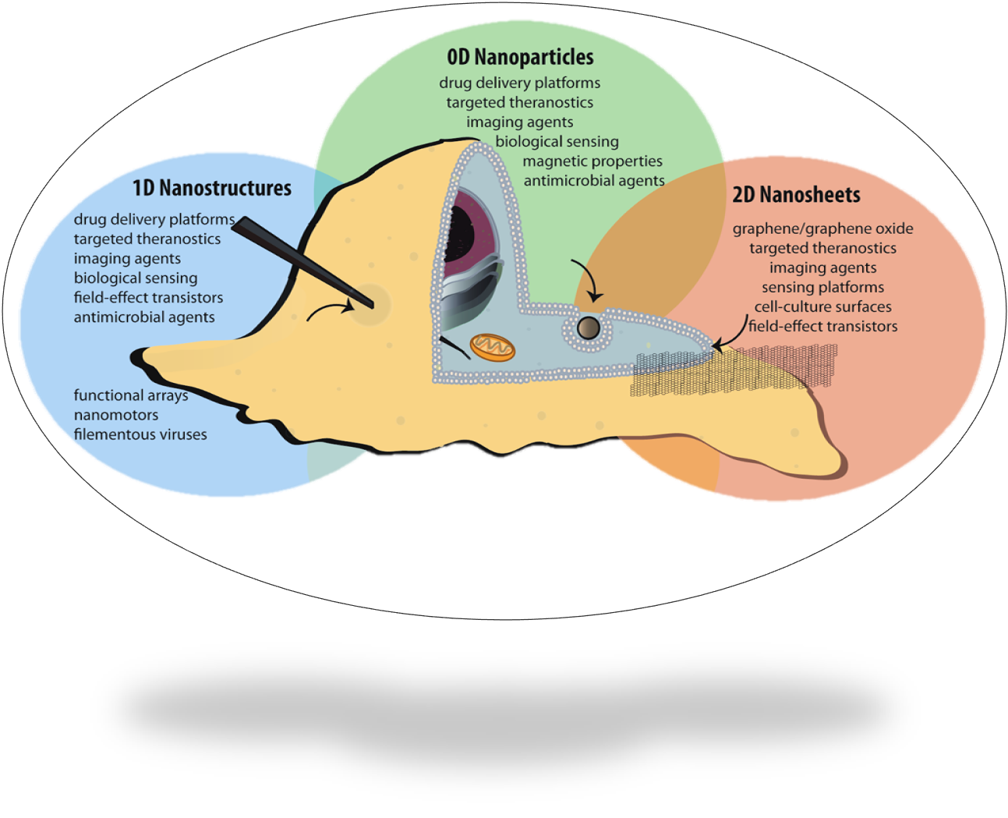by Nicola J. Rogers Simpson
The increased use of nanoparticles and nanomaterials does pose many questions in terms of health and safety because they behave quite unpredictably, and quite differently to the bulk material. Therefore, a lot of research is also conducted into the long-term health and environmental effects of nanomaterials.

