Electron Microscopy
Electron microscopes are not so different to light microscopes. Rather than using light to look at the sample, an electron microscope uses a beam of electrons.
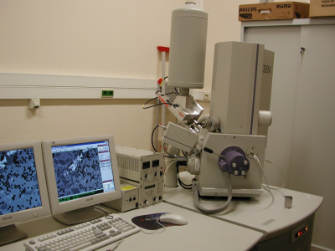
A scanning electron microscope at the University of Birmingham.
The advantage of a beam of electrons is that when they are travelling very fast their wavelength becomes very small. Wavelength is important in microscopy because the size limit of the things you can see depends on the wavelength of the beam you are using to look at them! The smaller the thing you want to look at, the smaller wavelength you need to probe it with.
With a scanning electron microscope (an SEM), you can magnify your image up to 500,000 times! Compare that to light microscopes that are normally limited to 2000 times.

Why 'scanning'?

SEMs get their name because they work by scanning the electron beam back and forth across a surface. Electrons in the beam collide with electrons in the atoms in the sample. The collision results in some electrons being ejected from the sample surface. These are detected and used to build up a picture of the surface.

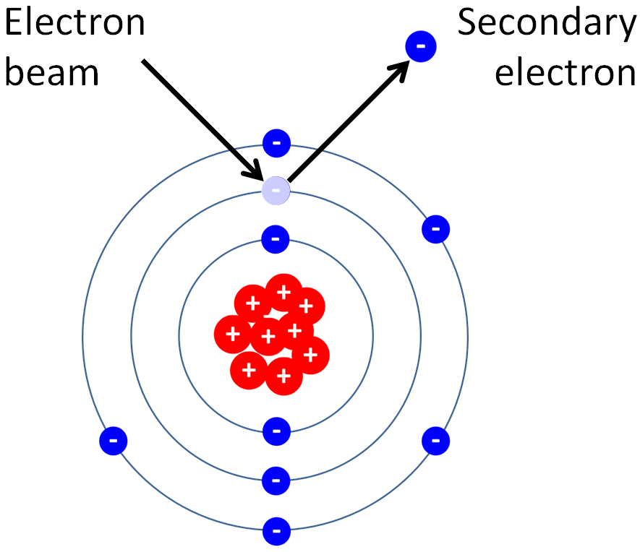
Generation of secondary electrons.

