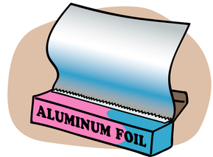
Properties of everyday materials
Name: ……………………………
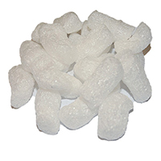
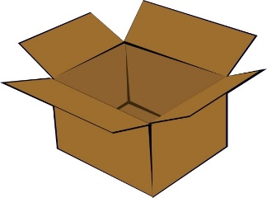
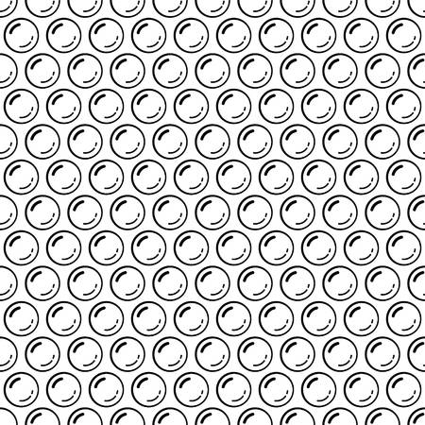

Material | Light or heavy? | Rough or smooth? | Stretchy or stiff? | Hard or soft? | Will it dissolve?
Newspaper
Foil
Packaging balls
Bubble wrap
Cardboard
Wrapping paper
Cotton wool
Plastic

Which materials are manmade? …………………………………………………………………………………….
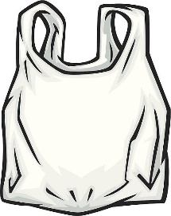
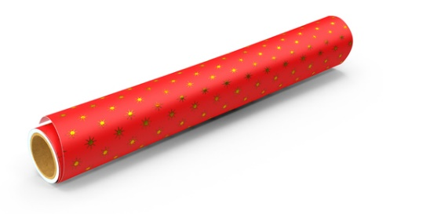
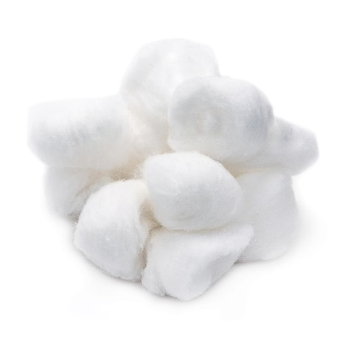
Which materials would be best for keeping something fragile safe? ……………………………………………

