Synchrotron

A synchrotron is a type of circular particle accelerator which produces high intensity electromagnetic radiation, of which the x-rays are mostly used. The x-rays are produced by accelerating electrons around the circular accelerator, close to the speed of light using magnets. The main “ring” is formed of straight sections and x number of bends. At each bend the electrons emit electromagnetic radiation (mostly in the form of x-rays) which are utilised uniquely by each beamline through the use of lenses, mirrors and monochromators (which allows a highly intense and specific wavelength of x-ray to be used).


Schematic of a synchrotron (Copyright © EPSIM 3D/JF Santarelli, Synchrotron Soleil).

The x-rays can be utilised in many ways, for example in x-ray diffraction whereby the atomic positions within a crystal to be evaluated. Whilst XAFS (x-ray absorption fine structure) and XANES (x-ray absorption near edge structure) can provide information about local structure and oxidation states.

There are many experiments which are not possible without a synchrotron due to the high intensity of the x-rays present. For example, laboratory x-ray diffraction requires at least 30 mins and the quality of data is too poor to obtain atomic positions. On the other hand, a scan obtained in a minute at a synchrotron allows for atomic position refinements. Also to study catalytic processes the time scale of a lab source is insufficient. Furthermore, synchrotrons provide many experimental environments difficult and expensive to run in a laboratory setting such as; high pressures, high temperatures, faster scans and cryocooling. Cryocooling is extremely important when studying biological samples as when subjected to x-rays these samples are prone to damage. Therefore, being able to cryo-cool preserves sample integrity.

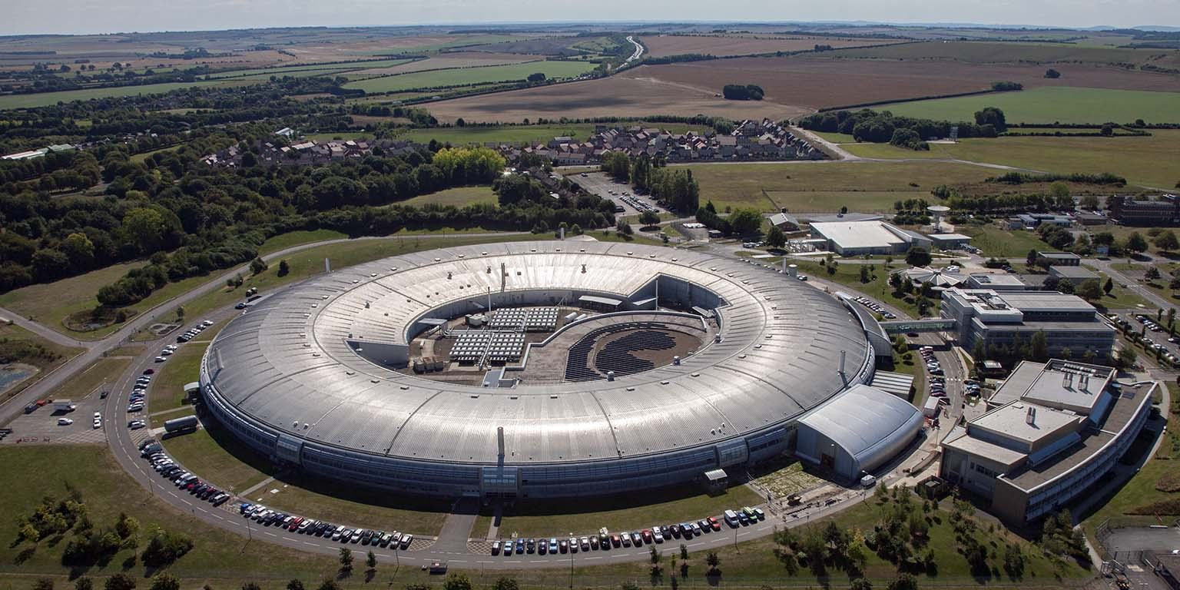
The diamond light source in Oxfordshire.

There are synchrotrons all over the world but the diamond light source in Oxfordshire is the UK's national synchrotron light source science facility (see link to learn more about the diamond light source; https://www.diamond.ac.uk/Home/About.html). Researchers at the University of Birmingham frequently use the synchrotrons facilities to help them in their research.

Learn more about the diamond light source here;
https://www.bbc.co.uk/programmes/w3csvrgt (a BBC Science in action Podcast featuring Zoe Schnepp at ~ 19 min).

