Thermogravimetric analysis (TGA)

Thermogravimetric analysis or thermal gravimetric analysis (TGA) is an analytical technique whereby the mass of a sample is measured over time, as the temperature changes. This technique can therefore be used by researchers as a means of analysing the thermal stability of a sample as well as the composition/purity of a sample.

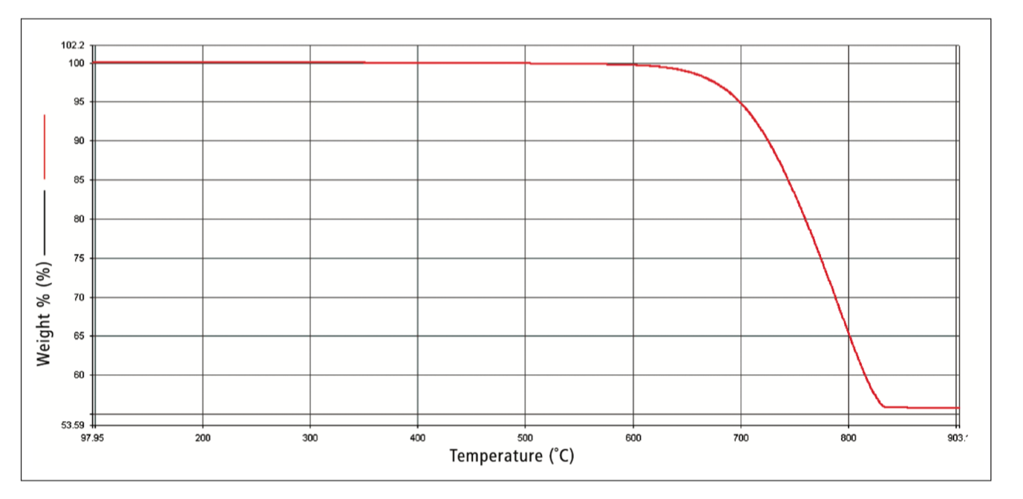

Above is a TGA thermal curve of calcium carbonate (CaCO₃) which has a molecular weight of 100 amu (atomic mass units). Upon heating past 600 ºC the CaCO₃ begins thermal decomposition whereby CaCO₃ CaO + CO₂. The solid phase CaO remains on the weighing balance thus giving a final reading of 56 amu, once all the sample has undergone the decomposition reaction (i.e. once the temperature has reached approximately 850 ºC).

To see the full calculations (the source material) and learn more about TGA see the link; https://www.perkinelmer.com/lab-solutions/resources/docs/FAQ_Beginners-Guide-to-Thermogravimetric-Analysis_009380C_01.pdf

