Green Solvents

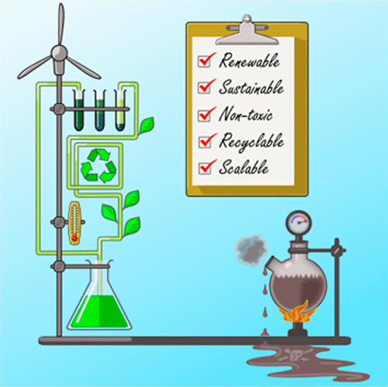
Solvents are receiving much greater attention now to try and make chemistry “more green”. This is because large volumes of solvent a used through-out the life cycle of even a 1 step synthesis; through the reaction to form the product, to then purifying and analysing it (purification especially needing large volumes of solvent). This is despite the solvent rarely being directly responsible for product formation (it usually just acts as a medium to bring the reagents together/separate them). Thus there is an obvious need to cut down on the volumes of solvent used especially since most are toxic, flammable, or environmentally damaging.

The best way to make solvents “more green” is to remove them completely. But this is only possible in a small amount of reactions (so called dry reactions). Another method is to try and use water as the solvent, however this requires the reagents and product to be water soluble and stable. Most organic reactions are not suitable to be performed in water!

Because most organic reactions require an organic solvent (i.e. not water), the main focus is on how to make the existing solvents used safer/greener. Here are some examples of this;

Ethanol is a common organic solvent which can be extracted from crude oil (a non-renewable source). It is possible now however to generate ethanol from agricultural crops such as corn, sugar beet and wheat where the ethanol is extracted in biorefineries. These renewable sources are a lot greener than extraction form crude oil. Learn more about “renewable ethanol” here; https://epure.org/about-ethanol/what-is-renewable-ethanol/

Benzene was once a commonly used solvent until it was formally recognised as a carcinogen (chemical that causes cancer after repeated exposure) in the mid 20th century. Now chemicals with similar properties to benzene are used which carry less of a health risk like cyclohexane and toluene.

Chlorofluorocarbons (CFC’s) are organic compounds that contains carbon, chlorine, and fluorine and were commonly used as analytical solvents (e.g. in NMR). This was until scientist made the link between the rising use of CFC’s (also used commercially in refrigerators and aerosols) and the depletion of the earth’s ozone layer. This then lead to the widespread banning of CFC’s. Now instead of using solvents such as CCl₄, scientist use relatively less environmentally harmful substitutes that do not deplete the ozone such as chloroform (CHCl₃) and dichloromethane (CH₂Cl₂).

To learn more about green solvents see this online open access article;
https://sustainablechemicalprocesses.springeropen.com/articles/10.1186/s40508-016-0051-z

