Nucleophilic substitution

Nucleophilic substitution is a reaction which involves a nucleophile reacting at an electron deficient position in a molecule. Electron deficiency in a molecule can occur though the polarisation of a bond, for example a halogen bonded to a carbon centre. This polarises the bond, with the halogen becoming partially negatively charged (δ⁻) and the carbon becoming partially positively charged (δ⁺). A nucleophile will readily attack this partially positively charged, electron deficient position. Once the attack occurs, the halogen acts as a leaving group and so dis-attaches from the molecule.

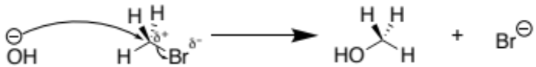

The example below highlights how an amine undergoes electrophilic substitution with bromomethane. Note how after each step the amine becomes more partially negativly charged due to the increasing number of electron donating methyl groups added which further increases the amines nucleophilic strength. Because after each substitution reaction the amine becomes more nucleophilic, the amine will keep reacting with the bromomethanes leading to the formation of a quaternary ammonium salt. These quaternary ammonium salts are often used as cationic surfactants.

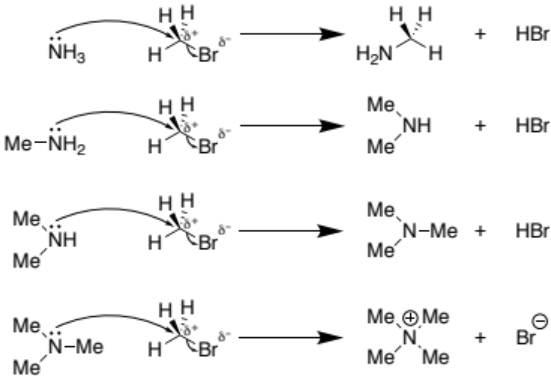

The examples of the nucleophilic substitution reactions so far have been S_{N}2 substitutions whereby; the S stands for substitution, N for nucleophilic, and the 2 because the initial stage of the reaction (the rate determining step) involves two species i.e. the nucleophile and haloalkane. In the S_{N}2 substitution the nucleophile attacks from the opposite side of the carbon to the leaving group. The reason why is quite complex and is a concept studied at university level chemistry. If you want to learn more, see the link;
https://chem.libretexts.org/Bookshelves/Organic_Chemistry/Map%3A_Organic_Chemistry_(Bruice)/08%3A_Substitution_Reactions_of_Alkyl_Halides/8.01%3A_The_Mechanism_For_an_SN2_Reaction

There is also S_{N}1 type nucleophilic substitution reactions which involve only 1 species in the initial rate determining step. This type of nucleophilic substitution occurs in tertiary substituted haloalkanes whereby attack of the nucleophile from the opposite side of the carbon isn’t possible due to the other groups bonded to the carbon centre blocking the attack. In this case the halogen dis-attaches to form a cationic species which is very electron deficient so is readily attacked by the nucleophile.

