Isomers

Isomers in general terms are molecules which have the same molecular formula (same number of atoms), but are arranged/displayed differently to give distinct structures.

Molecular formula; shows the actual number of each type of atom in a molecule e.g. C₂H₆
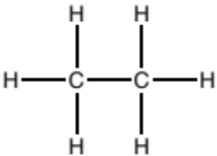
Structural formula; shows all the covalent bonds present in a molecule in 2 dimensions.

Structural isomer

Definition; structural isomers have the same molecular formula, but their atoms are arranged differently in space.

Structural isomers can be separated into 3 groups;

- Chain isomer; molecules with the same molecular formula, but different structures of the carbon skeleton in space.

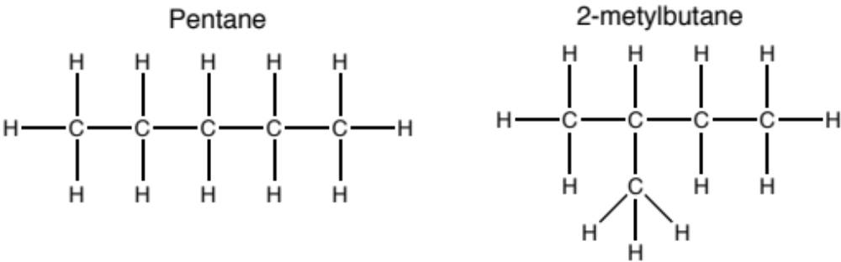
- Position/regio isomer; molecules with the same molecular formula, but different structures in space due to different positions of the same functional group on the same carbon skeleton.

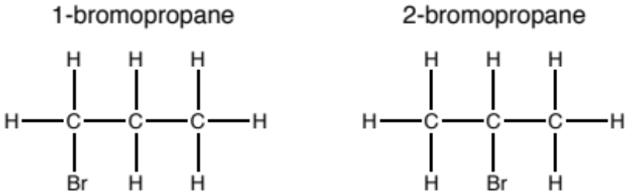

- Functional group isomer; molecules with the same molecular formula, but with atoms arranged to give different functional groups in space.

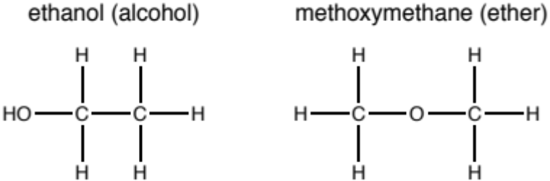

Stereoisomers

Definition; stereoisomers have the same structural formulae, but have a different arrangement of atoms in three dimensional space.

Stereoisomers can be separated into 2 groups;

- Geometrical (E-Z) isomers; occur due to restricted rotation around a alkene (C=C) double bond.
E-Z stereoisomers arise when:
- There is restricted rotation around an alkene (C=C) double bond.
- There are 2 different functional groups/atoms attached both ends of the restricted double bond

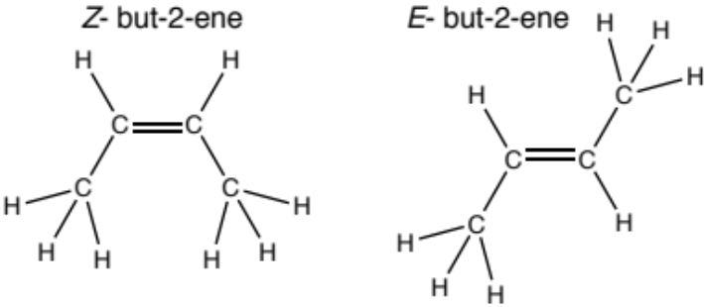
- Optical isomers; occur when there is a stereogenic centre in a molecule, i.e. an atom which is bonded to 4 different functional groups/atoms.
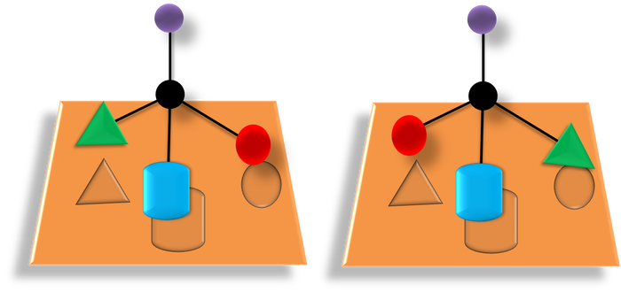

To learn more about optical stereoisomers; enantiomers and diastereomers see the chemBAM page; https://chembam.com/enantiomers-diastereomers/.

