Melting Point

Determining the melting point of a molecule or compound is a useful tool for chemists when analysing a substance. For example the melting point can help qualitatively determine a substances purity. A pure non-ionic, crystalline organic compound should have a narrow melting point range, approximately 0.5 ºC. However a substance which is not pure will have a larger range in comparison and will also likely melt at a lower temperature. A quantitative comparison between a sample and literature value can also be used to identify a compound as pure compounds have characteristic melting point ranges. However it helps to have some idea as to what the compound might be!

How to measure a melting point

The common method for taking the melting point of a solid organic compound is to take a small amount of the compound in a capillary tube and place it in a measuring apparatus. This apparatus gradually heats the compound using a heating bath from a set temperature. There is a lens to view the capillary in the heating bath to allow the scientist to determine when the solid has melted and thus determine the melting point.

It is good practise to record the range the compound has melted – i.e. from when it starts to melt, to when it has completely melted. Also its standard practise (& an effective use of time) to carry out a rapid melting point determination initially (i.e. by heating rapidly), to establish an approximate melting point. Then to carry out at least two further determinations through heating more slowly until two consistent ranges have been obtained.

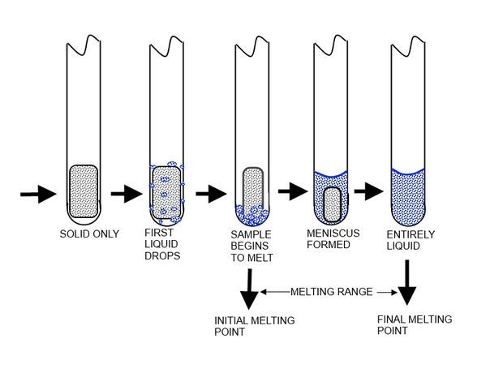
Image source; https://chemistryclinic.co.uk/1-9-melting-points-and-melting-ranges/

Science behind a melting point

The temperature at which a solid melts to become a liquid is the melting point. Melting requires the intermolecular forces that hold a solid together to be broken, thus the temperature a solid compound melts will depend on the structure and the nature of it intermolecular forces. For example common sugar (Sucrose) crystals are made up of intermolecular hydrogen bonds between the Sucrose molecules and have a melting point of 186 ºC. In comparison common salt (NaCl) is made up of stronger ionic bonds between the charged ions thus has a higher melting point of 800.7 ºC.
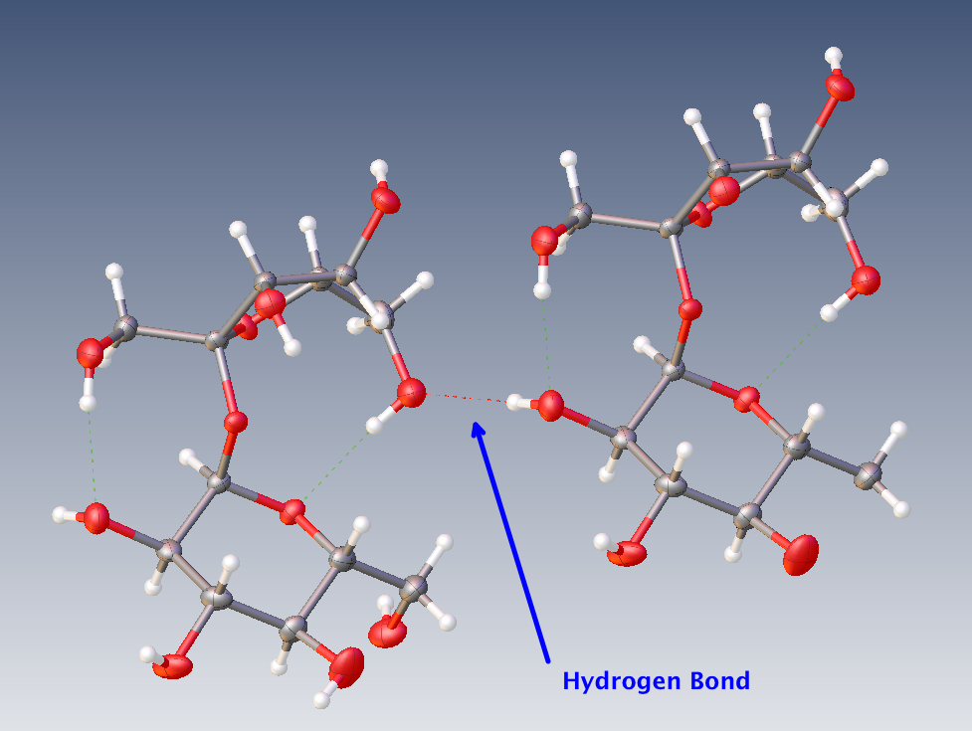
Common sugar (Sucrose) molecules interacting through hydrogen bonding (source; https://physics.stackexchange.com/questions/353904/why-does-sugar-form-a-crystal-structure).
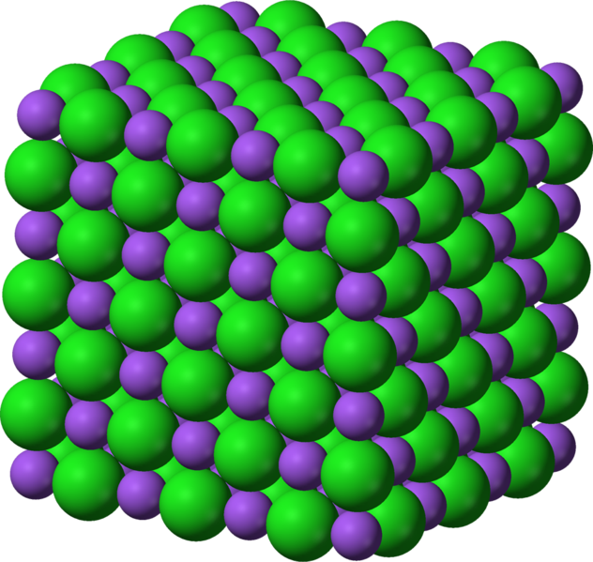
NaOH ionic crystal structure.

