Retrosynthesis (Aspirin & Paracetamol)

Retrosynthesis is a technique chemists use to identify how to synthesise a molecule through approaching the problem backwards. Effectively retrosynthesis starts from the wanted product and works backwards chopping and changing the molecule into smaller pieces to identify what the previous molecule can be made from. These “chopped up” molecules are referred to as synthons and are usually unstable ions, thus it’s important to identify a more stable equivalent molecule which would react in the same way. The trick to good retrosynthesis is knowing which bond to break, unfortunately this is something that comes with practise and experience!

What’s with the arrow?
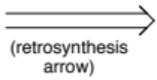
A retrosynthetic arrow is used to show retrosynthesis is taking place though the breaking of a bond and NOT a reaction. The retrosynthesis arrow allows a clear distinction between a reaction taking place and retrosynthetic analysis.

Below are two examples of how retrosynthesis can be applied to two common prescription drugs, aspirin and paracetamol.

Aspirin
As shown in the first diagram, aspirin 1 can be chopped up into synthons 2 and 3. One question here is why break the bond in the position shown. The answer is if the bond is broken here the equivalent molecules 4 and 5 can react together through a simple nucleophilic addition-elimination reaction. But for instance molecule 5 (ethanoic anhydride) could be a range of electrophiles which react to add a acetyl group to a molecule.

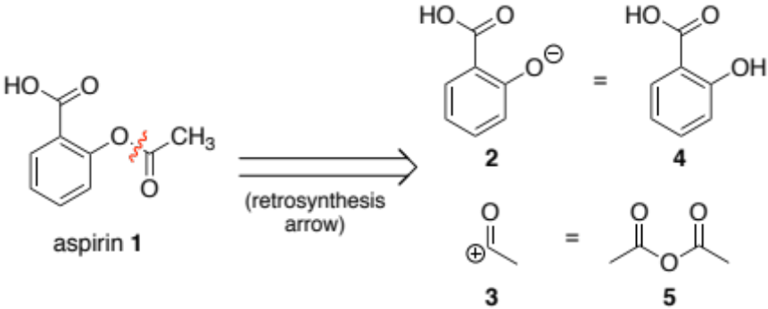

As shown in the second diagram, Salicylic acid 4 can be chopped up further into synthons 6 and 7. One big question here is why have the charges on the synthons that way around. The answer is if the charges are this way around, it is possible to react the equivalent molecules 8 and 9 together through electrophilic substitution. Also if the charges on synthons 6 and 7 were the other way around, it would make little sense chemically, as it is highly unlikely an electron rich benzene ring would act as an electrophile.

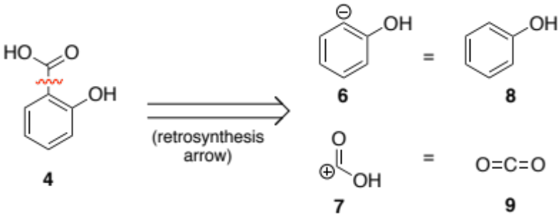

To summarise; aspirin can be taken back to common chemical starting materials, ethanoic anhydride 5, phenol 8 and CO₂ 9. Therefore the forward synthesis would be this;

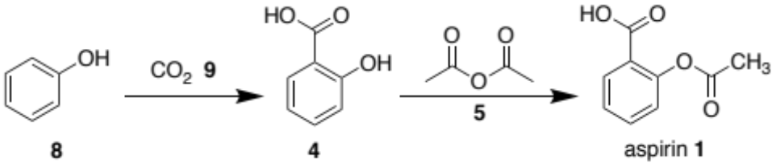

Paracetamol
As shown in the first diagram, paracetamol A can be chopped up into synthons B and C. One question here is why break the bond in the position shown. The answer is if the bond is broken here the equivalent molecules D and E can react together through a simple nucleophilic addition-elimination reaction as before.

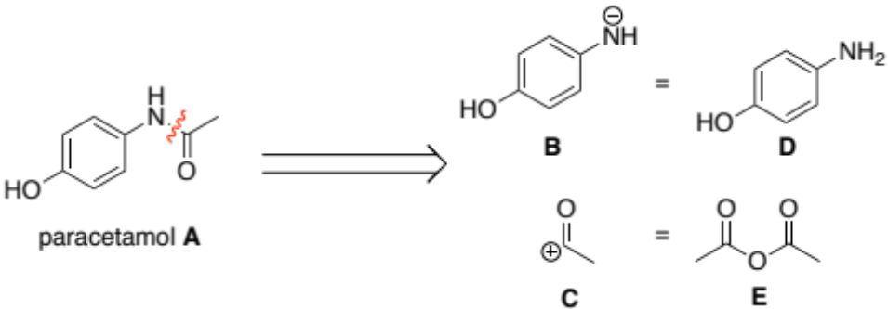

As shown in the second diagram, molecule D can be chopped up further into synthons F and G. One big question here is why has NO₂ appeared? The answer is that NH₂ is a poor electrophile (it usually acts as a nucleophile!). Therefore an equivalent electrophile for NH₂ would be NO₂ which can then be reduced to NH₂. Thus NO₂ can react with phenol (molecule H) through electrophilic substitution.

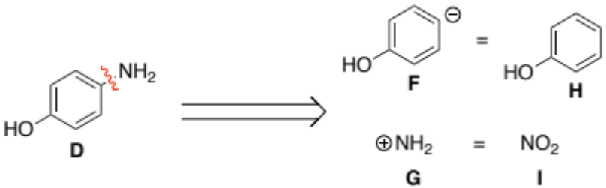

To summarise; paracetamol can be taken back to common chemical starting materials, ethanoic anhydride E, phenol H and NO₂ I. Therefore the forward synthesis would be this;

