Rotary Evaporator

What is it?

A rotary evaporator (sometimes abbreviated to rotavap) is a piece of equipment primarily used to remove solvent from a sample through “evaporation under reduced pressure”. The presence of reduced pressure in the apparatus causes the solvent (in the round bottom flask) to boil at a lower temperature than normal. Note, rotating the round bottom flask increases the liquid's surface area and thus the rate of evaporation. The solvent vapor travels into the cooler water condenser, where it condenses and drips into a separate receiving flask. This process is how the solvent is removed, therefore leaving a concentrated compound in the original round bottom flask.
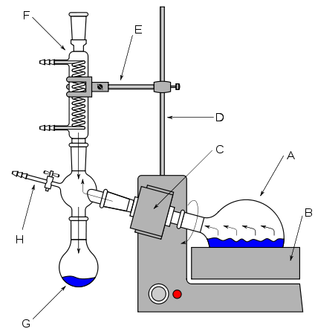
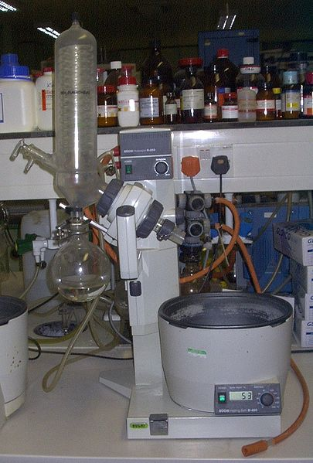

Image Image author left; Geni right; User:Harkonnen2. A) Round bottom flask B) Water bath C) Rotary motor F) Water condenser G) Receiving flask/collecting reservoir H) Tap connecting vaccum pump.

Why use it?

Rotary evaporation is often used for to remove solvents with relatively low boiling points such as EtOAc (ethyl acetate) and n-hexane from a sample. This is because a rotavap is simple to use, relatively quick to achieve solvent removal (depending on volume and solvent) and is found in most organic laboratories. It is also a lot more efficient than evaporation under atmospheric pressure.

However solvents such water or DMF (dimethylformamide) with relatively high boiling points are hard to remove with standard rotary evaporators and would require a vacuum system capable of achieving sufficiently low pressure. For this reason, water is often removed before putting a sample on a rotavap, through using drying agents such as MgSO₄ (magnesium sulphate).

How to use it?

The rotary evaporator is relatively simple to use, but the correct procedure should be followed.
- Turn on water bath and set to relevant temperature.
- Ensure water following into water condenser.
- Connect round bottom flask to rotavap. Remember to use clip to ensure flask doesn’t slip off!
- Turn on vacuum pump, then immediately close tap to put the system under reduced pressure.
- Turn on rotation.
- Briefly wait to see bumping occurs before lowering round bottom flask into water bath.
- Monitor round bottom flask until solvent is removed.

- Once complete, raise round bottom flask out of water bath and stop the rotation.
- Turn off the vacuum pump and immediately but carefully open the tap to release the system from reduced pressure.
- The round bottom flask should now be available to remove from the rotavap.

