Venom

What is venom?
Venoms are a mixture of different enzymes and toxins produced in specialised glands to be secreted by an animal. Primarily used for killing prey, the mixture of toxins work together to wreak havoc on an animal’s internal organs.
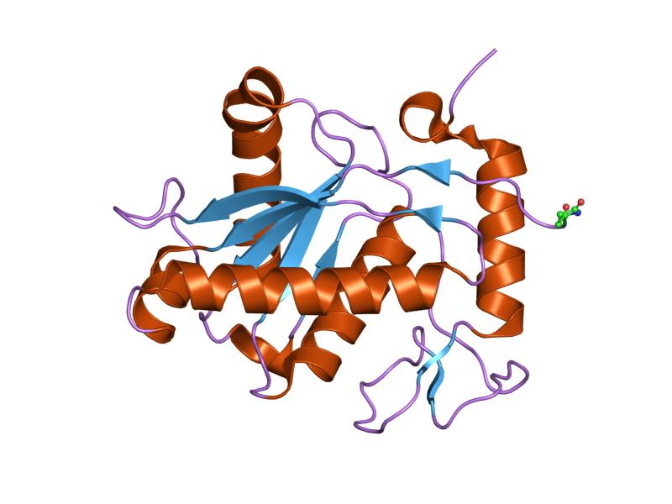
Some of the toxins which may be present in venoms are necrotoxins and cytotoxins which kill cells, myotoxins which damage muscle tissue and neurotoxins which alter the function of the nervous system.
metalloproteinase from Bothrops asper snake venom - https://www.ebi.ac.uk/pdbe/entry/pdb/1nd1

How do venoms work?
Snakes and spiders deliver their venom through fangs, scorpions through their stings and other animals use venomous spines. Once the venom has been injected under the skin or into a muscle, it does not go directly into the bloodstream but travels around the body through the lymphatic system. Once this system transports the venom to the subclavian vein in the neck, it can then enter the bloodstream. Therefore, if you get bitten or stung by a venomous animal, it is important to stay still as moving around will allow the venom to be transported much more quickly through the lymphatic vessels.
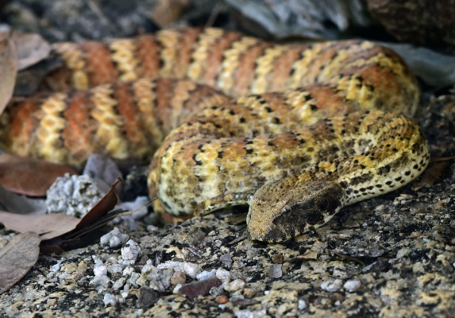
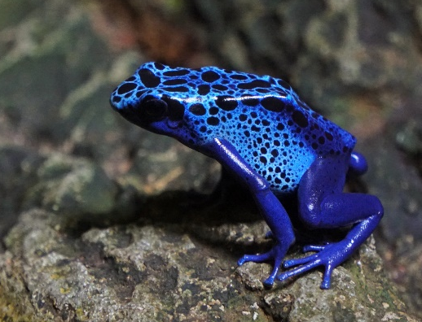
Interestingly, venom and poison are not the same. Venom is a specialised poison which is actively delivered, usually through a sting or bite, into an animal. Whereas poison is ‘passive’ and delivered through touch, ingestion or inhalation. So, some snakes are venomous as they inject a concoction of toxins into their prey when they bite but you would need to make physical contact with animals such as the poison dart frog to be poisoned. Although venom can be used as a defence mechanism, it is more likely that poison has this purpose.
Using venoms in pharmaceuticals
It is the dangerous toxins in venoms which make them pharmaceutically active and useful in many areas of medicine.
Antivenoms have been used since the 1890s to treat the bites and stings of venomous animals. They are produced by harvesting venom and exposing an animal to increasing dosages as it builds up a tolerance. The immune system will produce specific antibodies to defend against the toxins which are then harvested and processed into an antivenom. When injected into a person who has been bitten or stung, the antibodies will bind to the components of the venom, rendering it unable to damage cells in the body.
However, safe and effective antivenoms are rare and often expensive, meaning they are not available to many. So, there have been tales of people sucking the venom out of a bite or sting their friend has been given. This will not remove the venom and in some cases, may even transfer it through any cuts in the person’s mouth into their bloodstream. It is better to not touch the wound and seek medical assistance immediately.
Venoms are also being used in medications for the cardiovascular system. Synthesised from the venom of a type of Brazilian pit viper, Captopril was the first angiotensin-converting enzyme inhibitor to be developed. The drug is used to treat severe hypertension and, in some cases, heart failure. Another type of venom from a sea snail contains a unique insulin hormone which could be used to treat diabetes in humans. As well as this, any venom with anticoagulant components can be used in reducing the risk of thrombosis, strokes and heart attacks.
Much more research is needed but some potential applications of venom may be in treatments for cancer, skin conditions and autoimmune diseases. The possibilities for advancing medicine with the use of venoms are endless, especially as animals continue evolving to produce more potent poisons than ever before.

To learn more about the harmful effects of chemicals see the chemBAM page - toxicology

