The Chemistry of Paint

Many of the objects that we encounter in our day-to-day lives are painted. We define paint as a pigmented coating that, when applied to the exterior of an object, provides protection and/or decoration to the underlying substrate.
Whilst paint is used on many types of materials - from brick walls to stained glass windows - there is no one-size-fits-all when it comes to choosing the correct formulation for a specific application. One look in your average hardware store will quickly tell you how many types of paint exist; paint may be water- or oil-based, it may dry down to a matt, gloss or satin finish, or it may even be designed to prevent condensation or corrosion.

Take a look at the two images above. On the left we have a watercolour painting. The artist is primarily interested in the aesthetic of the paint - the opacity and intensity of the pigments, how different pigments layer and mix, and the textural finishes they produce. On the right we have a car. Although the mechanic is also interested in the overall aesthetic of the paint, they are particularly invested in its durability and resistance to oxidation and weather damage. Understanding the components that make up a paint and the effect that their properties have on performance is an entire industry in itself. In fact, as of 2020, it is estimated that the global paint and coating industry generates roughly $160 billion a year in revenue!

What is paint made of?
The main chemicals that comprise a paint can be split into four basic categories:
- Pigments
- Binders (Resins)
- Solvents
- Additives

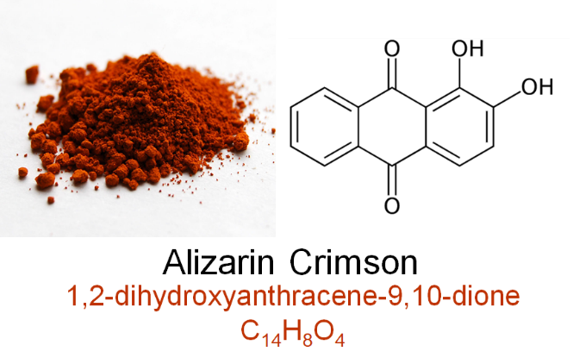
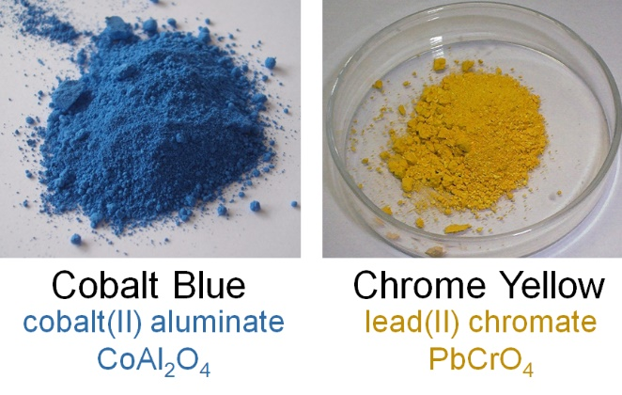
Pigments are coloured, insoluble compounds which give paint its colour and opacity.
Example of an organic pigment. Originally isolated from the madder plant, alizarin crimson is now synthesised from coal tar at a fraction of the cost
Each pigment absorbs certain wavelengths of light and reflects all others, producing the colour that we see. There are inorganic pigments, such as cobalt blue and chrome yellow, as well as organic ones such as carmine and crimson. Inorganic pigments are made from metals or metallic salts often derived from natural minerals or ores and typically provide longer lasting and brighter colour. Organic pigments are based on carbon chains which can be obtained from animals and plants but are more commonly synthesised from carbon-containing raw materials like natural gas or petroleum.
Examples of inorganic pigments
Binders, or resins, are the adhesives that “glue” pigments to a surface to form a film. The binder forms a matrix in which the pigment particles are dispersed evenly throughout. Although often used interchangeably, a dye is dissolved in a solvent whereas a pigment is held in suspension, so they are very different substances to scientists!
Binders may be natural or synthetic and are separated into two categories: oil/alkyd-based and water-based (i.e. acrylic and latex). Binders are responsible for many of the protective and decorative properties of the coating; therefore, the type and concentration of binder helps to determine the performance of a paint. High-quality paint contains a high concentration of binder. This not only promotes improved adhesion, but forms films that are more resistant to cracking and blistering. Certain binders can even provide resistance to ultraviolet (UV light) and abrasion.
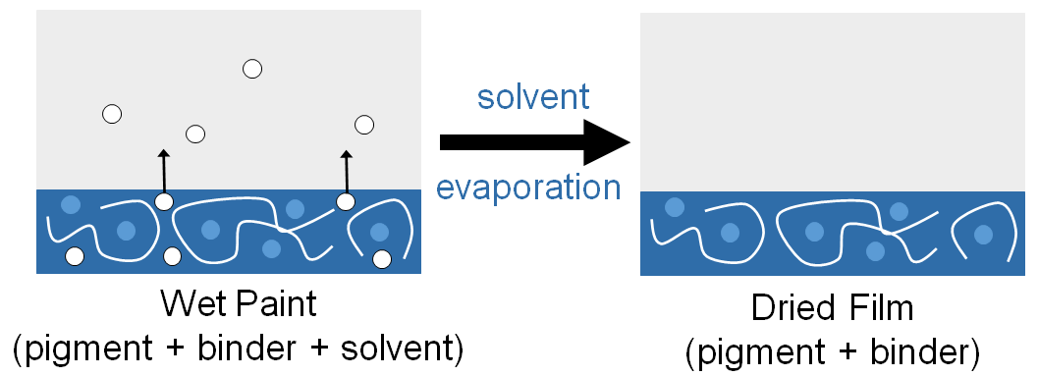
Whilst binders allow pigments to stick to surfaces, they are typically made from viscous chemicals that are difficult to work with. Imagine trying to coat a fence with a paint that has the consistency of honey! Solvents, also known as diluents or thinners, are often added to reduce the viscosity of the paint. The combination of binder and solvent are collectively referred to as the vehicle of the paint. The solvent is volatile: the solvent evaporates as the paint dries, leaving behind a film of pigment held in place by the binder. High-quality paints contain a higher ratio of solids (pigment/binder) to liquid (solvent), forming thicker, more durable films once dried. Solvents may be aqueous or organic depending on the whether the paint is water- or oil-based.

Additives are chemicals added to paint formulas to give them extra desirable properties. Just small amounts can have a huge impact on the final product. There are dozens of common additives - which ones are used depends on the purpose of the paint. For decorative paints, additives can be used to improve the appearance or texture, whereas paint for industrial use typically needs resistance to environmental conditions like temperature and UV light. Emulsifiers, defoamers and thickeners are all frequently used. Outdoor coatings for metallic surfaces contain anti-corrosives which help with longevity, and adding biocides can prevent paint spoilage by microorganisms. The use of these additives allows the paint and coatings industry to create hundreds of different products for a variety of different purposes.
Steel bridges are coated with anti-corrosive paints to protect the underlying metal from salt spray, oxygen and traffic pollutants

Bringing Chemistry to Art
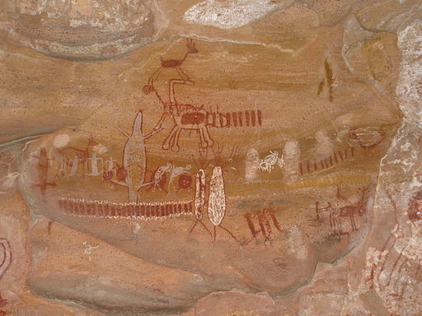
It is estimated to be 40,000 years ago that caves were first painted by tribes across the world to tell stories and mark territories. The paints used were made with organic pigments from plants and animals as well as inorganic pigments from minerals in the earth, held together by very simple binders like water and saliva. As time progressed, a huge variety of paints developed from these humble beginnings. Tempera paint, first thought to be developed by the Ancient Egyptians, is made of powdered pigment and egg yolk to give a fast-drying, smooth paint which can be built up in layers.
Cave painting at Serra da Capivara National Park, Brazil. Image source | CC BY-SA

Although tempera is still used today, oil paint surpassed tempera in popularity during the Early Renaissance. The production of different pigments was also widespread during this period because painters were often alchemists (early chemists) who would create their own paints by studying the chemistry of colour. It was these artists who discovered many of the pigments that we are familiar with today, including ultramarine and cadmium yellow, using analytical and experimental synthesis. Versatile synthetic paints such as modern acrylics are now widely used in a variety of industrial applications, as well as by artists, and even those of us who buy poster paint from the local craft store!

