The Chemistry of Gelatin

When you think of gelatin, chances are you think of jelly: the classic dessert famous for its elastic consistency and melt-in-the-mouth behaviour. In fact, in the 19th century, Scottish chemist Thomas Graham coined the word ‘gel’ – taken from the word gelatine – to describe the class of semi-rigid materials that consist of a liquid phase dispersed through a solid medium or network.
While gelatin is famous for its use in the food industry, it is an incredibly versatile protein that is used extensively in pharmaceutical and textile applications. These industries exploit gelatin’s ability to form cheap, flexible, and thermoreversible gels.

What is gelatin, and how is it obtained?
Gelatin is produced from the partial hydrolysis of collagen.
Collagen is the most abundant protein in the body. It is a key structural component in many of our tissues, including our tendons and our bones. This may, at first, sound contradictory – how can collagen provide structure to hard tissues like bone, when gelatin is, by definition, a gel? We can explain this phenomenon by looking at the secondary structure of both proteins.
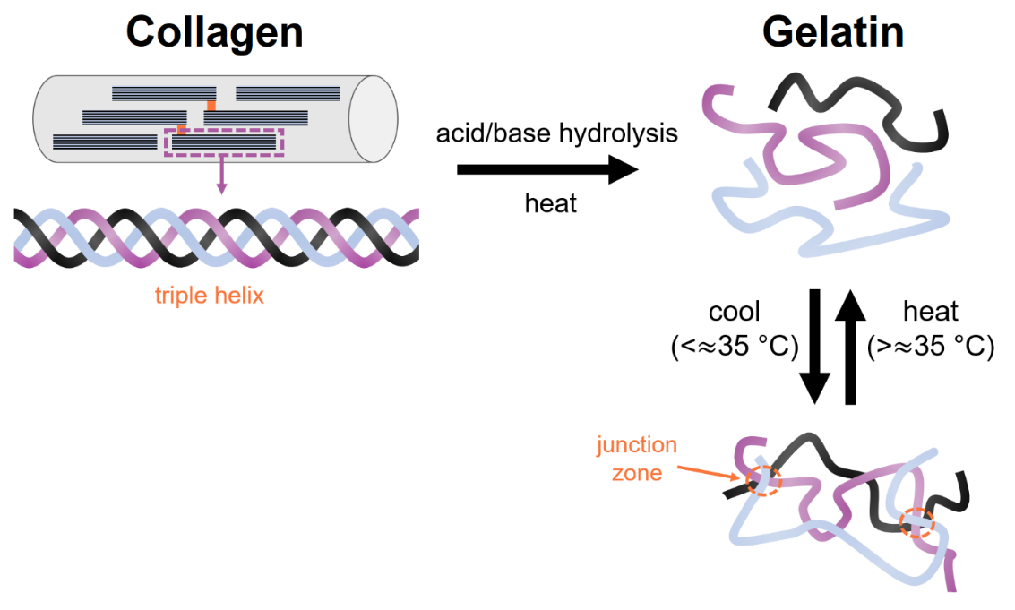
Gelatin and collagen exist as polypeptide chains, held together by hydrogen bonds between the amino acids of adjacent chains. The structural conformation that arises from these interactions is known as the secondary structure of the protein. Collagen consists of three polypeptide chains that intertwine tightly with one another to form a highly stable triple-helix conformation. These triple-helical molecules are then further organised into bundles of collagen fibrils. This high degree of organisation explains why collagen has superior mechanical properties, and why is it is primed to provide structure and support to many of the body’s tissues.
When collagen is hydrolysed under heat, the triple-helix unwinds, and the secondary structure is partially lost. This process is referred to as the denaturation of collagen – gelatin is simply denatured collagen. As collagen is insoluble in water, the hydrolysis reaction is catalysed under acidic or basic conditions. Two types of gelatin are therefore obtained: Type A (acid hydrolysis) and Type B (base hydrolysis).
When the gelatin solution is cooled below the sol-gel transition temperature, the polypeptide chains aggregate and attempt to regain their secondary structure. However, this structure is only partially reformed with respect to collagen. Regions where the triple-helices renature (reform) are called junction zones, while regions where the chains randomly coil are called amorphous.

So why does gelatin form a gel? The helical junction zones act as cross-links, allowing microscopic gelatin networks to form. We initially had a solution of gelatin; the water molecules are now trapped within the pores of the gelatin network. Gelatin is therefore an example of a colloid, where one phase is microscopically mixed within another phase. A gel is a specific type of colloid, where the liquid phase (in this case water) is dispersed within the solid phase (gelatin). As the dispersed phase is water, we often call these gels hydrogels.
Gelatin hydrogels can hold an extraordinary amount of water within their network without dissolving. This explains why jelly jiggles – the gelatin network retains the overall structural integrity, but the water phase prevents it from setting as a rigid solid. As soon as the temperature is raised above the gel-sol transition temperature, gelatin liquifies once more. It may surprise you to learn that gelatin itself is flavourless – flavour molecules trapped within the gelatin network are released once the jelly has melted in your mouth!

How is gelatin used in research?

Gelatin is biocompatible (non-toxic) and easily digestible. This makes it a useful material for pharmaceutical applications.
Drug and supplement capsules are often coated with gelatin to improve oral administration. The surface of the coating is smooth, making the medicine easier to swallow. Gelatin also helps to mask the unpleasant taste of the active ingredients held within the capsule.

Gelatin hydrogels have made their way into clinical trials as potential drug delivery agents. These gels are specifically engineered to carry and deliver medication to a target location in the body. Drug molecules are loaded into the pores of the gel matrix and subsequently released in response to environmental stimuli such as temperature and pH. Crucially, the drug is administered with controlled loading and release kinetics. Researchers often look at ways of chemically modifying gelatin, e.g. with different functional groups., to maximise the efficiency of the drug delivery process.

In recent years, gelatin hydrogels have also gained significant attention in the field of regenerative medicine. This is because the high-water content of these materials allows them to be used as wound dressings and artificial tissue replacements. Gelfoam®, a commercial gelatin-based dressing, is used to maintain moisture when applied to the surface of an open wound. This decreases both the risk of infection and the time required for healing. Furthermore, gelatin-based hydrogels have been investigated as potential bioinks for use in tissue engineering. As scientists work towards creating fully-functional, 3D printed organs, developing bioinks remains a vital area of biomedical research.

